1 to 62mcqs =62 marks
63 to 65 subjective=3*3 =9marks
66to 69 subjective=5*4 =20marks
Total paper 91 marks

1.The time between sale of inventory and collection of receivable.
a account receivable
b operation cycle
c inventory period
d none of above

2. allow a bank to substitute its creditworthiness for the customer, for a fee is called___________-

a open bank account
b commercial draft
c promisory note
d banker accetptance

3.Standard deviations for Investment A and Investment B are 25% and 12% respectively. This indicates that :
Select correct option:
Investment A is less volatile than Investment B
Investment B is equally volatile to Investment A
Investment A is more volatile than Investment B
Investment B is more volatile than Investment A

4. find the average 2%,5%,6%,8%
a 5%
b 5.25 %
c 6%
d 8%

5 what is standard deviation of thise averages 2%,5%, 7%
6.As the dividend is always same for a zero growth stock, so the stock can also be viewed as
7.Which of the following statement shows revenue, expense, and net worth as of a specific date?
a balance sheet
b income statement
c cashflow
d none of above
8. which of the following character is not a systematic risk
market risk
interest risk
inflation risk
strike call in a company
9. A company has a two director and 1 shareholder which hav 25 power of share the voter for director is
a 100
b150
c50
d25

10.An investment will be _________ if the IRR doesn’t exceeds the required return and _________ otherwise.
Select correct option:
Accepted; rejected
Accepted; accepted
Rejected; rejected
Rejected; accepted

11. Which of the following is the overall return the firm must earn on its existing assets to maintain the value of the stock?
Select correct option:
IRR (Internal Rate of Return)
MIRR (Modified Internal Rate of Return)
WACC (Weighted Average Cost of Capital)
AAR (Average Accounting Return)

12. Which of the following is the return that firm’s creditors demand on new borrowings ?
Select correct option:
Cost of debt
Cost of preferred stock
Cost of common equity
Cost of retained earnings

13.In which type of projects, the unequal lives of the projects do affect the analysis ?
Select correct option:
Mutually exclusive
Dependent
Independent
Correlated

14.Mr. Naveed has bought 100 shares of a corporation one year ago at Rs. 23 per share. Over the last year, he received a dividend of Rs. 1.50 per share. At the end of the year, the stock sells for Rs. 31. As per given information, what will be his total percentage return ?
Select correct option:
10.63%
20.20%
35.12%
41.30%

15.Which of the following is known as the group of assets such as stocks and bonds held by an investor ?
Select correct option:
Stock Bundle
Portfolio
Capital Structure
None of the given options

16. Suppose the initial investment for a project is Rs. 16 million and the cash flows are Rs. 4 million in the first year and Rs. 9 million in the second and Rs. 5 million in the third. The project will have a payback period of:
Select correct option:
2.6 Years
3.1 Years
3.7 Years
4.1 Years

17. find the cash cycle inventory period is 38 days account payabel period is 50 days and average accoun receivable period is 30 days
a.68
b 18
c 80
d 118

Question 63= operating cash flow of Rs. 200,000. Net working capital has
decreased by Rs. 50,000 and there is a net capital spending of Rs. 0 during the year. Calculate total cash flow. (3marks)
Solution:
Total cash flow=200000-(-50000)
toal cash flow =250,000

Question 64= snk company find the profitability index dividend 2 and price= 200 (3marks)
solution= 2/200=0.01=1answer

question 65=3marks
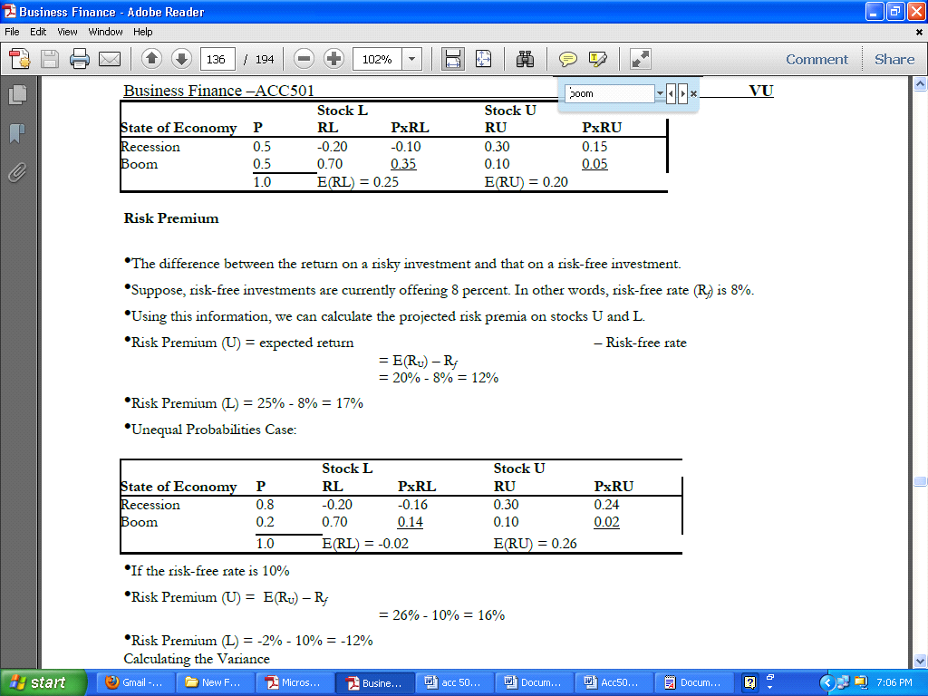

question 66= define systematic risk and unsystematic risk and also define which risk is eliminated by diversification 5 marks

Quesion 67= which issue cover in finance and investment area 5marks
questin 68= credit policy and its component 5makrs
question 69= define optimal policy 5marks

